Show Me Tell Me Questions and Answers
Approved Driving Instructor Since 1997
The Show Me Tell Me questions test your knowledge of basic car maintenance and safety. At the start of the practical driving test the Show Me Tell Me questions will begin. The driving test examiner will ask you two questions, one Show Me question and one Tell Me question. Answer any of those two questions incorrectly and you will gain one driving test fault. There are 19 different questions, which can be asked in 18 different combinations. Don't worry if you get a bit confused with the questions as they will all be covered off in my lessons in preparation for your driving test. To book your lessons with Meena’s School of Motoring ring 0774 772 5026 or email learn2drive@msmleeds.co.uk
Q1. Open the bonnet, identify where you would check the engine oil level and tell me how you would check that the engine has enough oil.
A. Identify the dipstick, pull it out and check the oil level against min/max markings
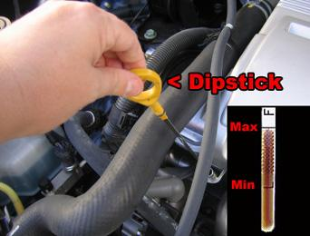
Q2. Show me/explain how you would check that the power assisted steering is working before starting a journey.
A. If the steering becomes heavy the steering may be faulty. Before starting a journey two simple checks can be made:
1) Gentle pressure on the steering wheel, maintained whilst the engine is started, should result in slight but noticeable movement as the system begins to operate.
2) Turning the steering wheel after just moving off will give an immediate indication that the power assisted steering is functioning correctly.
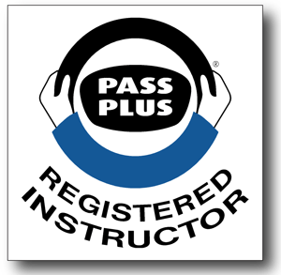
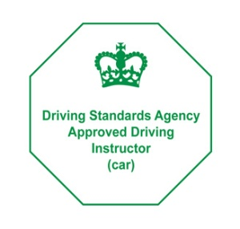
Page 1
Show Me Tell Me Questions and Answers
Q3. Show me how you would check the parking brake for excessive wear?
A. Apply the brake, when it is fully applied it should secure itself.
Q4. Show me how you would check that the direction indicators are working correctly?
A. Activate the indicators or hazard warning lights and walk around the car to see if all the indicators are working correctly
Q5. Open the car bonnet, identify where the brake fluid reservoir tank is and tell me how you would check that you have a safe level of hydraulic brake fluid.
Approved Driving Instructor Since 1997
A. Identify the hydraulic brake fluid reservoir tank and check the brake fluid level against the minimum / maximum level indicator.
Q6. Open the bonnet, identify where the windscreen washer reservoir is and tell me how you check the level?
A. Identify the reservoir, lift off the cap and make a visual check of level as there are no external markings on reservoir
Q7. Show me how you would check that the horn is working (off road only)?
A. Press the horn and listen (turn on ignition if necessary)
Q8. Show me how you would check that the brake lights are working on this car?
A. Operate brake pedal, make use of reflections in windows, garage doors, etc or ask someone to help (may need to switch ignition on, prompt not to start engine).
Q9. Show me how you would clean the windscreen using the windscreen washer and wipers?
A. Operate control to wash and wipe windscreen (turn on ignition if necessary).
Q10. Show me how you would set the demister controls to clear all the windows effectively, this should include both front and rear screens?
A. Set all relevant controls including; fan, temperature, air direction/source and heated screen to clear windscreens and windows. The engine does not have to be started for this.

Page 2
Show Me Tell Me Questions and Answers
Approved Driving Instructor Since 1997
Q11. Show me how you switch your headlight from dipped to main beam and explain how you would know the main beam is on whilst inside the car?
A. Operate switch (with ignition or engine on if necessary), check the main beam warning light.
Q12. Show me how you would switch on the rear fog light (s) and explain when you would use it/them (No need to exit the vehicle)?
A. Operate switch (turn on dipped headlights and ignition if necessary), check warning light is on. Explain use.
Q13.Open the bonnet, identify where you would check the engine oil level and tell me how you would check that the engine has enough oil?
A. Identify the dipstick, pull it out and check the oil level against min/max markings
Q14.Tell me how you would check that the brakes are working before starting a journey?
A. As you move off check the brakes. They should feel spongy and the car should not pull to one side.
Q15.Tell me how you would check that the headlights and tail lights are working?
A. Turn on lights (Turn on ignition if necessary), walk around the car and check that the lights are on.
Q16.Tell me where you would find the information for the recommended tyre pressures for this car and how tyre pressures should be checked.
A. Information will be found using the car manufacturer’s manual. Check the tyre pressures by using a reliable pressure gauge when the tyres are cold. Don't forget the spare and remember to refit the valve caps.
Q17. Tell me how you would make sure your head restraint is correctly adjusted so it provides the best protection in the event of a crash?
A. The head restraint should be adjusted so that the rigid part of the head restraint is at least as high as the eye or the top of your ears, and as close to the back of the head as is comfortable.
Q18. Tell me how you would check the tyres to show that they have sufficient tread depth and their general condition is safe to use on the road?
A. A safe tyre will have no cuts or bulges. The tread depth should be at least 1.6mm across the central ¾s of the breadth of the tyre and around the entire outer circumference
Q19.Tell me how you would know if there was a problem with your anti-lock braking system?
A. Warning light should illuminate if there is a fault with the anti-lock braking system
Page 3

